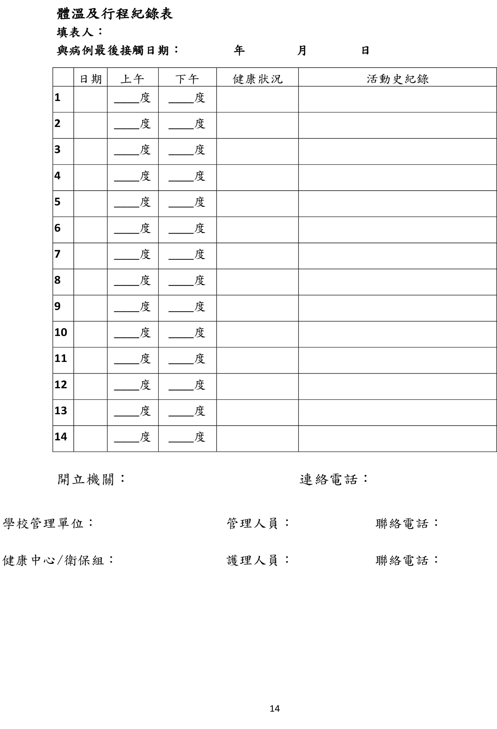

Body Temperature and Activities Record
Name：
ID No.：_____________________ _
Student No.：____________________
Department：____________________
End date of autonomous health management：Month Day_ Year ______

Day | Date | AM | PM | Health Condition | Activities
1 |  | °C | °C
2 |  | °C | °C
3 |  | °C | °C
4 |  | °C | °C
5 |  | °C | °C
6 |  | °C | °C
7 |  | °C | °C
8 |  | °C | °C
9 |  | °C | °C
10 |  | °C | °C
11 |  | °C | °C
12 |  | °C | °C
13 |  | °C | °C
14 |  | °C | °C

Issued by (Institution)： Tel：05-2720411#12345

